LEAP YEAR

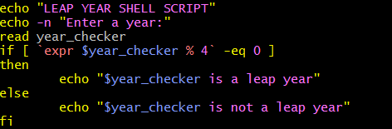

OUTPUT

